TESI SPERIMENTALI IN ERASMUS DI BIOCHIMICA

BERLINO – BERNHARD LOLL

Tesi sperimentale presso il laboratorio del prof. Bernhard Loll

Department of Biology, Chemistry, Pharmacy / Institute of Chemistry and Biochemistry
Biochemistry

Research
The Structural Biochemistry group investigates the molecular mechanisms, by which RNAs and proteins cooperate to bring about the biological functions of ribonucleoprotein complexes (RNPs; for an example see Figure). RNPs include some of the most complex macromolecular machineries of living cells, such as ribosomes and spliceosomes, which constitute fascinating objects to study the interplay of molecular conformation and biological function. Furthermore, RNPs act at the heart of numerous fundamental cellular processes, including virtually every aspect of gene expression and control. Finally, RNPs provide glimpses at the molecular ancestry of modern cells, which most likely evolved from an RNA-dominated world. Ultra-structural analysis of molecular RNP machines and their components using X-ray crystallography provides deep insights into their molecular mechanisms and suggests novel routes for their functional analysis.
PROGETTO ERASMUS IN CORSO:
Caratterizzazione e cristallizzazione della proteina HSD17B7 espressa in E. coli
Per il background sulla proteina HSD17B7 SITO DEL DIPARTIMENTO progetti di tesi del prof. Balliano

MADRID – VICTOR CID

Gennaio 2015 Progetto di Victor Cid (Madrid) per la studentessa che sta per partire

Ciao, Roberta.
…………….
………………..

About WHAT you will do, there are some topics that could be interesting to follow currently in our hands. One of them involves site-directed mutagenesis of yeast protein kinase C to eliminate putative MAPK phosphorylation target sites. I am attaching here a paper for you so that you understand better... It may look complex at the beginning, but don't panic: you will understand all of it in the end.
In Fig. 3 of the Mascaraque et al paper (attached), we found that hyperactive Pkc1 is hyperphosphorylated. What is exciting is that some of the phosphorylated residues (serines 226, 577 and 657) match Proline-directed sites (red arrows), meaning that they could be target sites for the downstream MAP Kinase Slt2. Your work could be focused on proving whether this is the case. So specific experiments would be:
- To study putative mobility shifts in Pkc1 by immunoblot in the presence and absence of the MAPK under different stimulation conditions.
- To develop non-phosphorylatable and phosphomimetic (changes to Ala and Asp) by site directed mutagenesis of those series and study their influence in the function of the protein.
...And some other things in this context. The idea is to prove that there
exists (or not) a feedback loop in the cell wall integrity pathway exerted by the downstream MAPK on Pkc1 (you can read Levin et al for a review on the pathway: available at
http://www.ncbi.nlm.nih.gov/pubmed/22174182).
It's a cool project.
If you agree on this scheme, a title could be:
"Mutagenic analysis of putative MAPK target sites in protein kinase C in
Saccharomyces cerevisiae".
I am copying to Maria Molina and Humberto Martin, who are our partners in
crime in this project.
Let us know your feelings & plans for your visit.
Cheers,
Victor.

MADRID – ALMUDENA PORRAS

Universidad Complutense Madrid

Departamento de Bioquímica y Biología Molecular II

Grupo Almudena Porras
Research Overview
Our main interest is the study of signal transduction mechanisms controlling different physio-pathological processes such as cancer and cardiovascular diseases. In particular, we are currently characterized the role played by p38 MAPK and C3G in the regulation of cell migration and invasion in different cell models and how they do it. We are also trying to explore the function of C3G in cardiomyocytes and whether C3G-mediated changes in platelets have an impact on angiogenesis and in the development of ischemic processes (myocardial infarction/stroke).
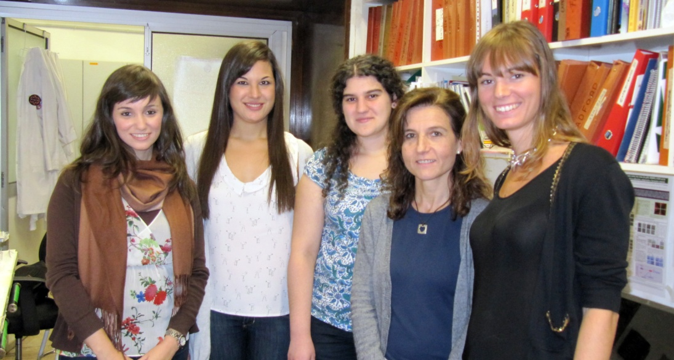

(http://www.ucm.es/biomol2/grupo-almudena-porras)

UTRECHT – EEFJIAN BREUKINK

Research of Eefjan Breukink - Utrecht
Bacterial cell wall synthesis
The bacterial cell wall synthesis pathway is the most accessible essential pathway of bacteria and hence a very important target for antibiotic development. The pathway starts in the cytosol with the synthesis of two UDP-activated precursors UDP-GlcNAc and UDP-MurNAc-pentapeptide (see figure). This is followed by the assembly of the complete peptidoglycan subunit on a polyisoprenoid carrier, undecaprenyl phosphate, resulting in a product called Lipid II, the ultimate peptidoglycan precursor. Lipid II is then transported to the exterior side of the plasma membrane and used by bi-functional penicillin binding proteins (PBPs) for the synthesis of the cell wall. The resulting undecaprenyl pyrophosphate is then recycled back to the cytosol, de-phosphorylated after which it is ready to be used again. Our research mainly focuses on the membrane events of this cycle and the different projects are outlined below.
Mode of action of (l)antibiotics
With the ever-increasing prevalence of antibiotic resistance and the almost empty antibiotic pipelines of the pharmaceutical industry, there is a great need for the development of new antibiotics. In designing such new antibiotics, it is generally viewed optimal to look at the antibiotics that bacteria themselves use in their fight for survival. Evolutionary forces have shaped and continue to shape these antibiotics into excellent weapons. By learning how they work, new targets can be identified and we might be able to design better versions or even completely new antibiotics and so keep ahead in the arms race against resistant bacteria. As such, detailed investigation into the working mechanisms of lantibiotics has been lagging behind over the past years. We aim to reveal novel lantibiotic’ (validated) targets, which then may be used for the development of novel antibiotics. Most likely, these targets represent essential proteins or molecules that play a vital role in important cellular processes. Alternatively, we will reveal novel ways to inhibit known targets, from which, again, novel antibiotics may be designed.
Specific labeling of camelid antibody fragments (VHHs) for imaging, therapeutic and research applications
A special type of antibody fragments can be obtained from Llama glama. These animals contain next to their conventional repertoire, antibodies that lack their heavy chain without loss of specificity or affinity. The variable domains of these heavy-chain only antibodies are indicated as VHH or nanobodies. The molecular size of the nanobody is approximately 15 kDa and specific nanobodies can be selected by phage display and produced in microorganisms as yeast or E. coli. This makes them ideal for modern Chemical biology-based site-specific labeling techniques that would allow an almost infinite number of applications for these molecules in scientific and healthcare settings. This is a project funded by an UU-focus and massa grant within the nanobullet consortium and Remko van Vught is aiming here to specifically functionalize these VHHs for multiple applications. In this respect it should be noted that Eefjan Breukink is affiliated to a small start-up company named QVQ that aims to develop these VHHs for imaging and research purposes.

UTRECHT – TOON DE KROON

Research of Toon de Kroon Utrecht
∗ Membrane lipid homeostasis
Membrane lipid composition determines the physical properties of biological membranes that are crucial for maintaining the membrane barrier and for the functioning of membrane proteins. Research in the group is aimed at understanding the principles that govern bulk membrane lipid composition and at identifying the underlying sensor-effector modules. These topics are investigated in the model eukaryote S. cerevisiae using biochemical, molecular biological, genetic and chemical biological approaches.
∗ Regulation of membrane intrinsic curvature
By gradually reducing the content of phosphatidylcholine (PC) from 40 % to below 1% of total membrane phospholipids we identified a novel regulatory mechanism for membrane lipid composition in yeast. The loss of the bilayer lipid PC is compensated for by a rise in the non-bilayer preferring lipid phosphatidylethanolamine (PE). Mass spec analysis revealed that PC depletion is accompanied by dramatic changes in the acyl chain composition of PE that reduce its non-bilayer propensity. Thus, the intrinsic membrane curvature of the membranes is maintained in the optimal range. Tine Michels is facing the challenge to elucidate the underlying sensing mechanism and regulatory network.
∗Metabolism of phospholipids at the molecular species level
Pulse labeling with stable isotope-labeled precursors and subsequent analysis of phospholipid species by ESI-MS/MS demonstrated the occurrence of PC remodeling by acyl chain exchange. We now want to identify the phospholipases and acyltransferases involved, with the ultimate aim of solving the function of PC remodeling. In a related project funded by the Barth Syndrome Foundation the acyl chain remodeling of the mitochondrial lipid cardiolipin by the transacylase Taz1p is investigated.
∗Structure-function analysis of the methyltransferase Opi3p
Opi3p is a 23 kD integral membrane protein of the ER that catalyzes the 2nd and 3rd methylation in the conversion of PE to PC. Matthijs Kol is addressing the catalytic mechanism and the membrane topology of this enzyme.
∗Detection of lipid-protein interactions by photocrosslinking
New technology has been developed based on photocrosslinking and click chemistry for detecting lipid-protein interactions in a biological membrane of interest. Short chain lipid analogues mimicking PC equipped with a photoactivatable moiety attached to the headgroup and containing azide-modified acyl chains for detection by click chemistry, have been successfully used to identify established and potential new interaction partners of PC in yeast mitochondrial membranes.
Nanocapsules of platinum anticancer drugs
In the area of bionanotechnology, the group develops lipid formulations of platinum anticancer drugs for drug delivery. Cisplatin nanocapsules are unique self-assembled nanoparticles consisting of a core of solid cisplatin coated with a lipid bilayer that exhibit unsurpassed cytotoxicity against cancer cells in vitro. The increased cell killing depends on uptake by caveolae-mediated endocytosis. Research goals include extending the technology to other platinum-based compounds and optimizing the formulation for in vivo testing.

TURKU - MATTI POUTANEN

Turku – Finland

Prof. Matti Poutanen

Turku Center for Disease Modeling

Focus in services in advanced animal models
TCDM is a research and research service organization at the Faculty of Medicine, University of Turku, and is part of the Bio Center Finland “Model Organisms” network. TCDM applies and provides state-of-art research facilities and expertise in studies in experimental animals to support both academic and industrial associated non-clinical research. The facilities and expertise are also available for contract research.

Disease Models
TCDM focuses on genetically modified mice and tumor xenografts as models for human diseases. Disease models are of key importance in studying the disease
- mechanisms
- progression and development
- prevention and treatment
- analyzing the drug candidates before clinical trials

Progetto in collaborazione:
Caratterizzazione di modelli animali HSD17B7-deficient
- per il background sull’enzima HSH17B7 andare su sito del dipartimento proposte di tesi caratterizzazione dell’enzima steroide reduttasi HSD17B7

